******Veer Narmad South Gujarat University**

**Udhna Magdalla Road, Surat – 395007, Gujarat, [INDIA].**

**Department of Information and Communication Technology M.Sc. (ICT) Programme**

PROJECT TITLE



**EVENTPALACE**

**AS PARTIAL REQUIREMENT FOR THE DEGREE**

**OF**

**MASTER OF SCIENCE IN INFORMATION AND COMMUNICATION TECHNOLOGY (MSC ICT 2 Year Course)**

**2024-25**

**SEMESTER-1**

GUIDED BY: SUBMITTED BY:

MS. Maitri Hingu Gupta Om R.

Salunke Dhruv V.



**Department of Information and Communication Technology**

**M.Sc.(Information and Communication Technology) Programme**

***Certificate***

This is to certify that Mr./Ms. **Gupta Om Rajesh** with exam seat number 1056 and PG Enroll Number **R24110018000710056** worked on his/her project work entitled as **EventPalace** at **Department of ICT** as a partial fulfillment of requirement of M.Sc. (Information and Communication Technology) - 1st Semester, during the academic year 2024-2025.

Date: 26/12/2024

Place: Department of ICT, VNSGU, Surat

Internal Project Guide Head of the Department

MSc(ICT) 1st Semester Department of ICT

Department of ICT VNSGU, Surat

VNSGU, Surat

**ACKNOWLEDGEMENT**

The successful completion of this project, **EventPalace**, would not have been possible without the support, guidance, and encouragement of numerous individuals. We owe the success of this comprehensive endeavor to the combined efforts of a team of dedicated individuals who made it a reality.

First and foremost, we would like to express our heartfelt gratitude to the **J.P. Dawer Institute of Information Science & Technology, Surat**, for providing us with this incredible opportunity to work on a real-time project.

We extend our deepest thanks to **MS.** **Maitri Hingu**, our professor and project coordinator, for her unwavering support and guidance throughout the development of this project. Her expertise, patience, and ability to steer our ideas in the right direction have been invaluable in bringing **EventPalace** to life. She has been a constant source of encouragement, always ready to provide solutions whenever needed, for which we express our sincere gratitude.

Finally, we wish to acknowledge all those, named or unnamed, who have extended their cooperation—whether directly or indirectly—in the development of this system. Every contribution, big or small, has been instrumental in making **EventPalace** a reality

Thanking All.

**GUPTA OM R.**

**SALUNKE DHRUV V.**

**INDEX**

|  |  |  |
| --- | --- | --- |
| **SR.**  **NO.** | **Description** | **Page No.** |
| **1** | **Introduction**   * 1. Objective of the System   2. Problem Definition   3. Core Components   4. Project Profile   5. Advantages of the Proposed System   6. Future Enhancement   7. Project Scope |  |
| **2** | **Requirement Gathering and Requirement Analysis**   * 1. Requirement Gathering   2. Feasibility |  |
| **3** | **System Design**   * 1. Entity Relationship Diagram   2. Use Case Diagram   3. Activity Diagram   4. Class Diagram   5. Sequence Diagram   6. Database Design |  |
| **4** | **Interface Design**  4.1 Detailed Design Description |  |
| **5** | **Testing** |  |
| **6** | **Bibliography** |  |

# 1.Introduction

EventPalace is an advanced venue booking system that allows users to book spaces such as halls, plots, and event venues seamlessly through electronic devices like computers, mobiles, and laptops using the internet.

EventPalace makes it possible for individuals or organizations to search, compare, and book venues more flexibly while providing an efficient and enjoyable user experience with an elegant interface.

* 1. Objective of the System
* Simplifying the process of venue booking for users.
* Providing a seamless and elegant interface for easy navigation.
* Improving efficiency and accessibility for venue management.
* Offering flexible booking options to meet diverse user needs.
* Enabling remote venue selection and booking.
* Reducing the time and effort required for on-site venue inquiries.
* Supporting administrative tasks related to venue bookings.

### Problem Definition

* Event management and venue booking are often cumbersome processes requiring physical visits and numerous phone calls, which can be time-consuming and inefficient.
* The traditional method of venue booking lacks a centralized system, making it difficult for users to compare and choose venues effectively.
* Manual processes lead to inefficiencies in managing bookings, availability, and communication between venue owners and customers.
* The absence of an automated system creates challenges for remote users who may not have the flexibility to visit venues physically.
* High dependency on intermediaries often increases the cost and complexity of booking venues.
* Lack of clear and accessible information about venue features, pricing, and availability adds to the user frustration.
* Unorganized administrative tasks for venue owners result in scheduling conflicts and missed business opportunities.

**EventPalace** addresses these challenges by offering a streamlined, user-friendly, and fully digital venue booking solution.

### Core Components

* Venue Management System (VMS): A platform where venues are listed, enabling users to browse, book, and manage their reservations seamlessly. It includes features for tracking availability, pricing, and booking history.
* Content Creation and Delivery: Tools for venue owners to showcase their spaces effectively, including high-quality images, virtual tours, detailed descriptions, and pricing information.
* Smart Recommendations: A system that suggests venues to users based on their preferences, budget, location, and type of event, optimizing the booking experience.
* Booking and Payment Mechanisms: Secure methods for users to reserve venues, make payments, and manage transactions, ensuring a hassle-free process for both users and venue owners.
* Collaboration and Communication Tools: Features that facilitate interaction between users and venue owners, such as messaging, real-time chat, and notifications for updates or confirmations.
* Data Analytics and Reporting: Insights for venue owners and administrators to analyze bookings, user behavior, and revenue trends, enabling better decision-making and improved service delivery.

### Project Profile

(A) Project Profile

|  |  |
| --- | --- |
| **Project Title** | EventPalace |
| **Front-End** | JSF, Prime Faces |
| **Back-End** | MySQL 5.7.16 |
| **Hardware Requirement** | Processor of 800 MHz Pentium (R), Minimum 512 MB RAM and Above, Minimum 40 GB Hard Disk and Above and Mouse, Keyboard. |
| **Software Specification** | Front End Software: Net beans-13 Back End: MySQL 5.7.16 Operating System: Windows 11 |
| **Development Tools** | Net beans-13, MySQL 5.7.16  Payara server |
| **Submitted By** | Mr. Om Gupta  Mr. Dhruv Salunke |

### Advantages of the Proposed System

* Flexibility: Users can book venues at their convenience, anytime and anywhere, based on their schedules.
* Cost-effectiveness: Streamlined booking reduces costs associated with intermediaries and manual processes.
* Convenience: Users can explore, compare, and book venues from the comfort of their homes or offices.
* Time Management: Simplifies the process of booking venues, saving time that would otherwise be spent on phone calls or in-person visits.
* Communication: Users can directly interact with venue owners through in-app messaging or notifications, improving communication.
* Efficiency: Venue owners can manage bookings, payments, and customer interactions more efficiently through automated systems.

### Future Enhancement

* Mobile App Development: Develop a dedicated mobile app for **EventPalace**, allowing users to book venues, view availability, and manage bookings on the go.
* Gamification Elements: Integrate gamified features like rewards, badges, and challenges to engage users, encourage repeat bookings, and create a fun venue selection experience.
* Virtual Reality (VR) Integration: Incorporate VR technology to offer virtual tours of event spaces, allowing users to experience venues remotely in an immersive way.
* AI-Powered Personalization: Use AI algorithms to recommend venues based on user preferences, past bookings, and event type, enhancing the booking experience and streamlining the decision-making process.

### Project Scope:

###### Admin can manage:

 Verify owner

* Feedback Management
* Query Management

###### Owner Can Manage:

* Upload venue
* Add Venue
* Review Management

###### User:

 Browse Venue

* View venue facility
* view venue images
* Book venue
* Make advance payment
* Make final payment
* Review
* Receive booking confirmation

1. **Requirement Gathering & Analysis**

### Requirement Gathering

I have gathered information about venue booking systems and analyzed various features that make the process seamless and user-friendly. The **EventPalace** system ensures flexibility, reliability, and financial efficiency for both venue owners and users. It allows users to book venues with ease while providing venue owners with an efficient way to manage bookings and payments.

In this project, I have used the following technology:



### Feasibility

The feasibility of the **EventPalace** project has been assessed based on time, technology, and project scope.

##### Time:

The project can be completed within 3 months, making it feasible within the given timeframe.

##### Technology:

Built using Java, the project is technically sound with minimal risk, ensuring feasibility.

##### Project Size:

The moderate project size makes it manageable, and the scope is achievable within the planned timeline.

## System Design

### Entity Relationship Diagram

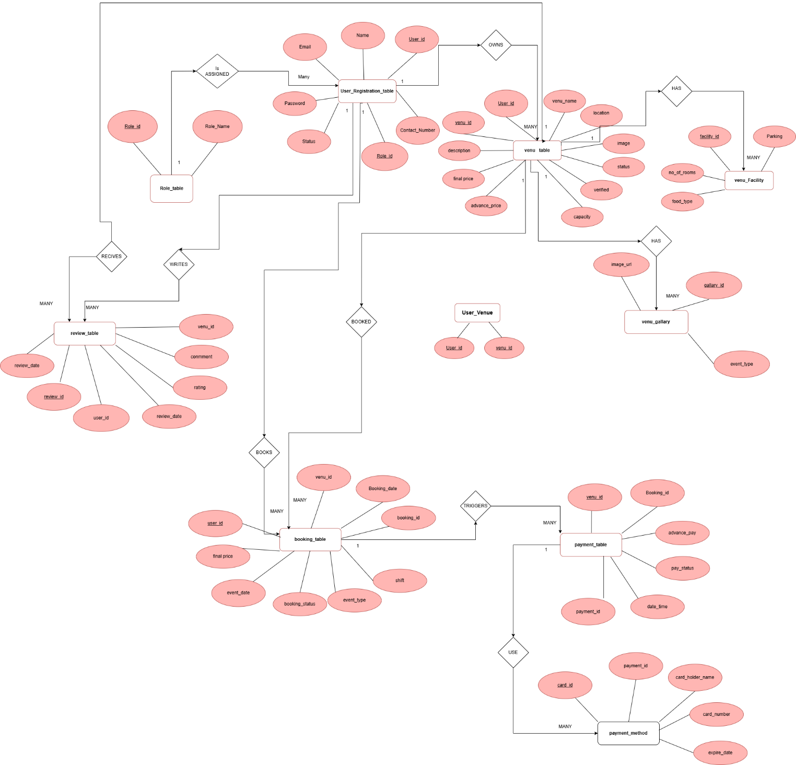

* 1. Use Case Diagram

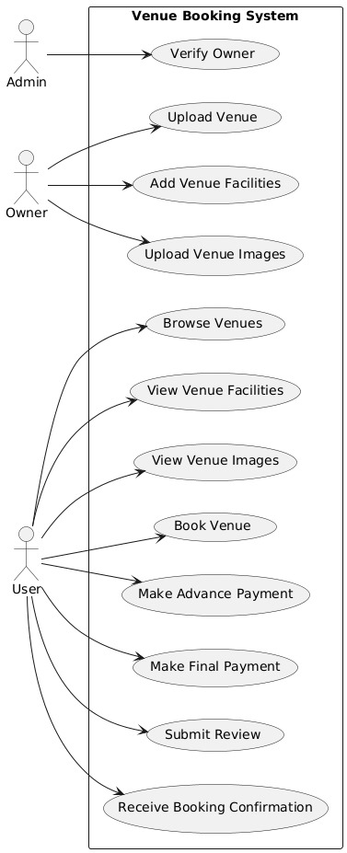

### Class Diagram

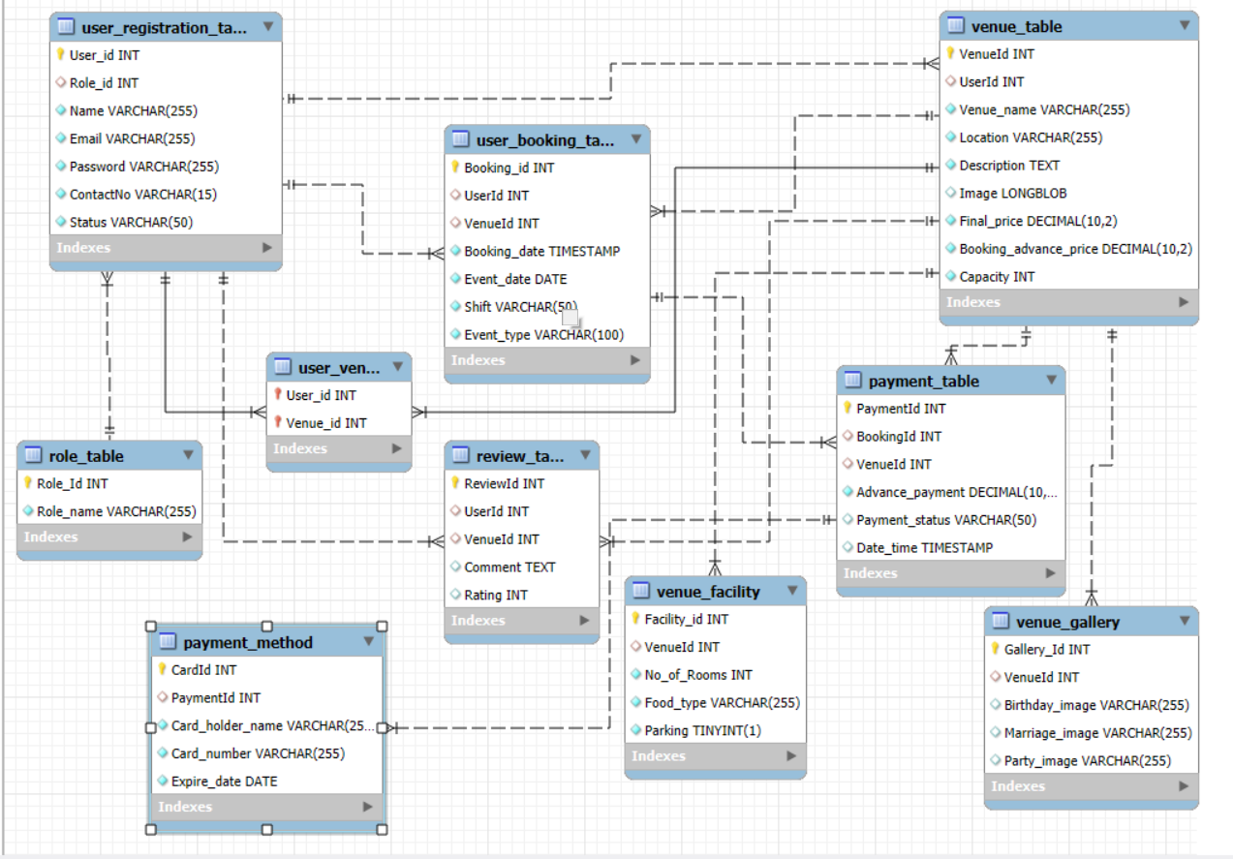

3.5 Sequence Diagram

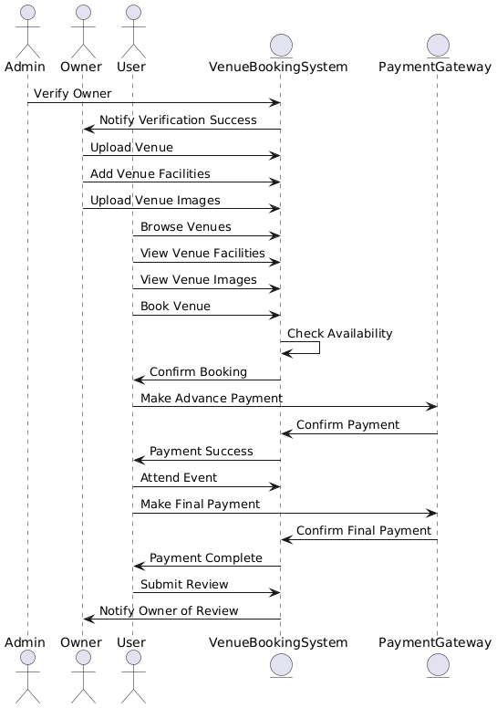

* 1. Database Design

1. **Role_table**

|  |  |  |
| --- | --- | --- |
| Column | Data Type | Constraints |
| Role_Id | INT | PRIMARY KEY |
| Role_name | VARCHAR | NOT NULL |

1. **User_Registration_table**

|  |  |  |
| --- | --- | --- |
| Column | Data Type | Constraints |
| User_id | INT | PRIMARY KEY |
| Role_id | INT | FOREIGN KEY REFERENCES Role_table(Role_Id) |
| Name | VARCHAR | NOT NULL |
| Email | VARCHAR | UNIQUE, NOT NULL |
| Password | VARCHAR | NOT NULL |
| ContactNo | VARCHAR | NOT NULL |
| Status | VARCHAR | NOT NULL |

1. **Venue_table**

|  |  |  |
| --- | --- | --- |
| Column | Data Type | Constraints |
| VenueId | INT | PRIMARY KEY |
| UserId | INT | FOREIGN KEY REFERENCES User_Registration_table(User_id) |
| Venue_name | VARCHAR | NOT NULL |
| Location | VARCHAR | NOT NULL |
| Description | TEXT | NOT NULL |
| Image | VARCHAR | DEFAULT ('default_image.jpg') |
| Final_price | DECIMAL | NOT NULL |
| Booking_advance_price | DECIMAL | NOT NULL |
| Capacity | INT | NOT NULL |

1. **user_registration and Venu (Many to Many)**

|  |  |  |
| --- | --- | --- |
| Column | Data Type | Constraints |
| User_id(FK) | INT | PRIMARY KEY(user_Registration) |
| Venu_id(FK) | INT | PRIMARY KEY(Venu_table) |

1. **Venue_Facility**

|  |  |  |
| --- | --- | --- |
| Column | Data Type | Constraints |
| Facility_id | INT | PRIMARY KEY |
| VenueId | INT | FOREIGN KEY REFERENCES Venue_table(VenueId) |
| No_of_Rooms | INT | NOT NULL |
| Food_type | VARCHAR | NOT NULL |
| Parking | BOOLEAN | NOT NULL |

1. **Venue_Gallery**

|  |  |  |
| --- | --- | --- |
| Column | Data Type | Constraints |
| Gallery_Id | INT | PRIMARY KEY |
| VenueId | INT | FOREIGN KEY REFERENCES Venue_table(VenueId) |
| Birthday_image | VARCHAR | DEFAULT ('birthday_default.jpg') |
| Marriage_image | VARCHAR | DEFAULT ('marriage_default.jpg') |
| Party_image | VARCHAR | DEFAULT ('party_default.jpg') |

1. **User_Booking_table**

|  |  |  |
| --- | --- | --- |
| Column | Data Type | Constraints |
| Booking_id | INT | PRIMARY KEY |
| UserId | INT | FOREIGN KEY REFERENCES User_Registration_table(User_id) |
| VenueId | INT | FOREIGN KEY REFERENCES Venue_table(VenueId) |
| Booking_date | DATE | NOT NULL |
| Event_date | DATE | NOT NULL |
| Shift | VARCHAR | NOT NULL |
| Event_type | VARCHAR | NOT NULL |

1. **Payment_table**

|  |  |  |
| --- | --- | --- |
| Column | Data Type | Constraints |
| PaymentId | INT | PRIMARY KEY |
| BookingId | INT | FOREIGN KEY REFERENCES User_Booking_table(Booking_id) |
| VenueId | INT | FOREIGN KEY REFERENCES Venue_table(VenueId) |
| Advance_payment | DECIMAL | NOT NULL |
| Payment_status | VARCHAR | CHECK(Payment_status IN ('pending', 'complete')) |
| Date_time | TIMESTAMP | DEFAULT CURRENT_TIMESTAMP |

1. **Payment_Method**

|  |  |  |
| --- | --- | --- |
| Column | Data Type | Constraints |
| CardId | INT | PRIMARY KEY |
| PaymentId | INT | FOREIGN KEY REFERENCES Payment_table(PaymentId) |
| Card_holder_name | VARCHAR | NOT NULL |
| Card_number | VARCHAR | NOT NULL |
| Expire_date | DATE | NOT NULL |

1. **Review_table**

|  |  |  |
| --- | --- | --- |
| Column | Data Type | Constraints |
| ReviewId | INT | PRIMARY KEY |
| UserId | INT | FOREIGN KEY REFERENCES User_Registration_table(User_id) |
| VenueId | INT | FOREIGN KEY REFERENCES Venue_table(VenueId) |
| Comment | TEXT |  |
| Rating | INT | CHECK(Rating BETWEEN 1 AND 5) |

## 4.Interface Design

Home Page:

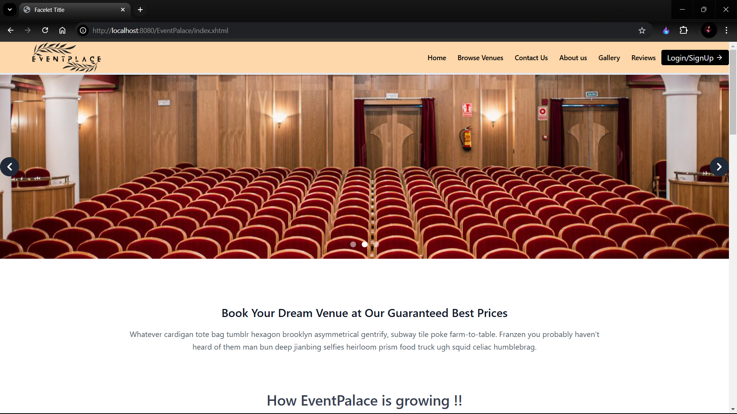

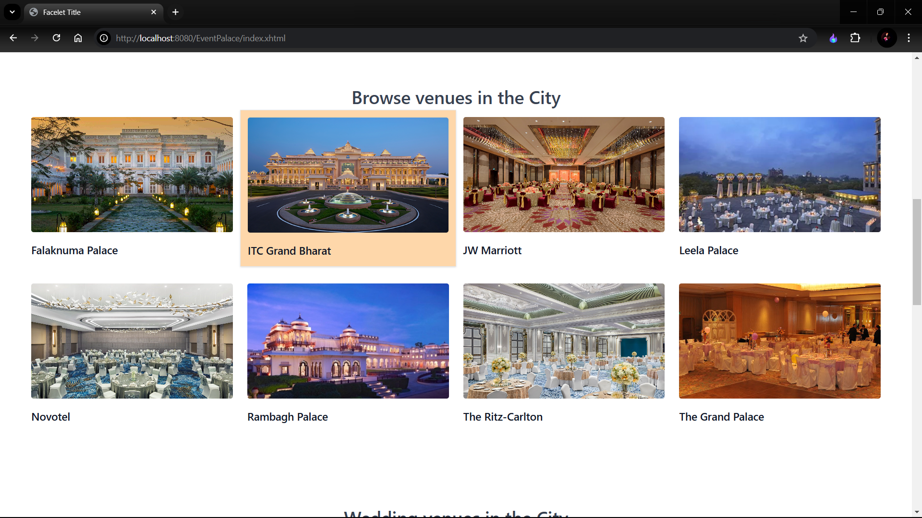

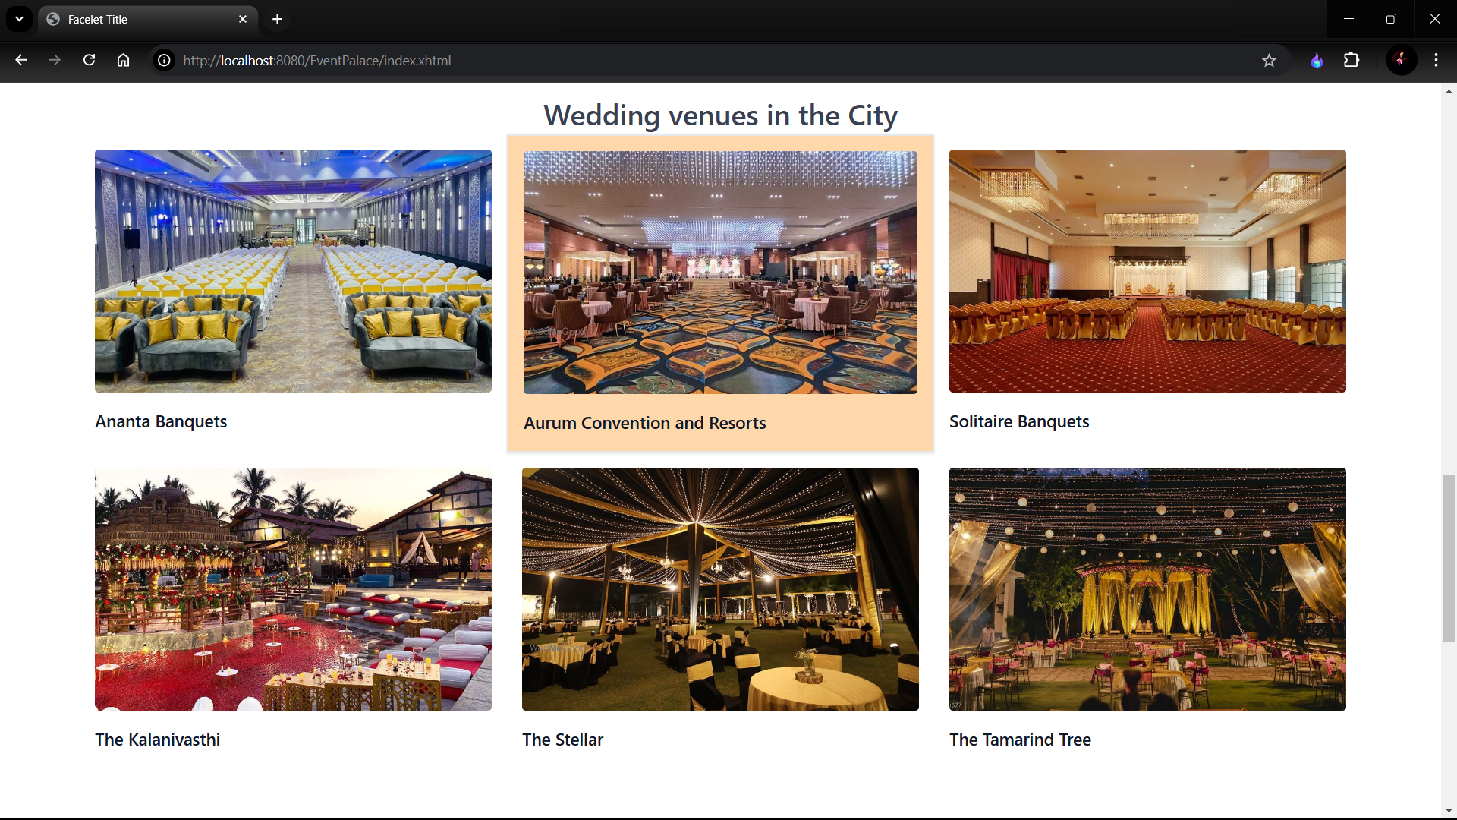

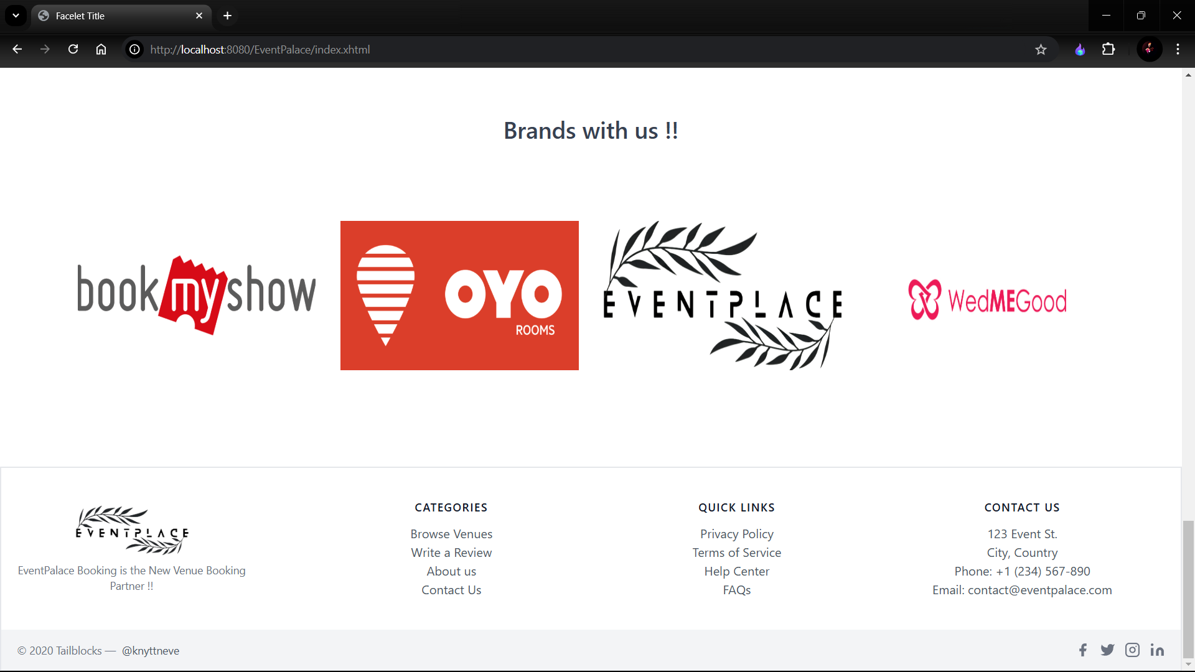

Browse Venues:

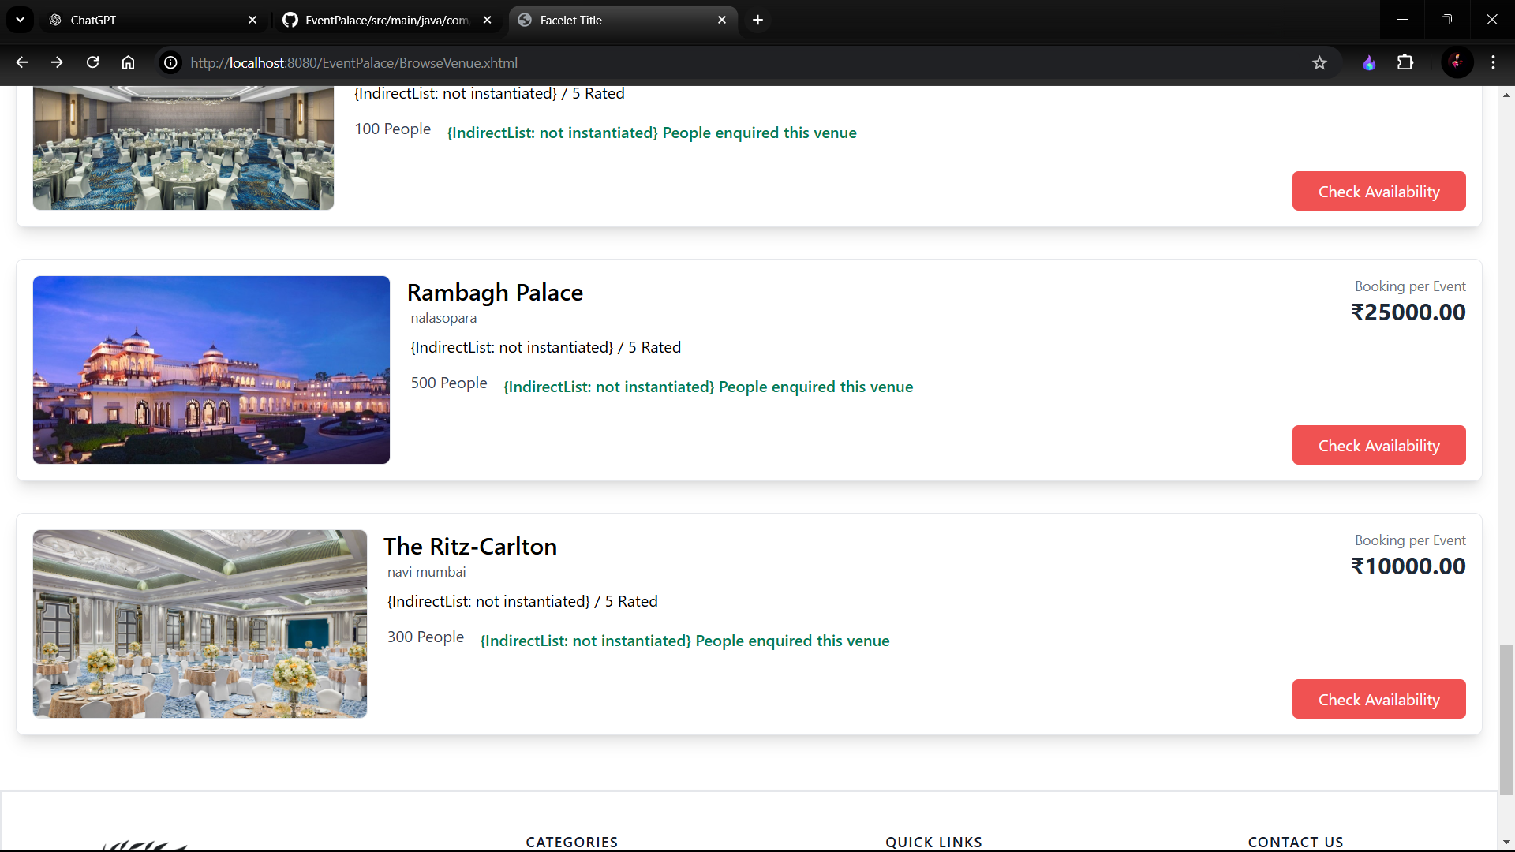

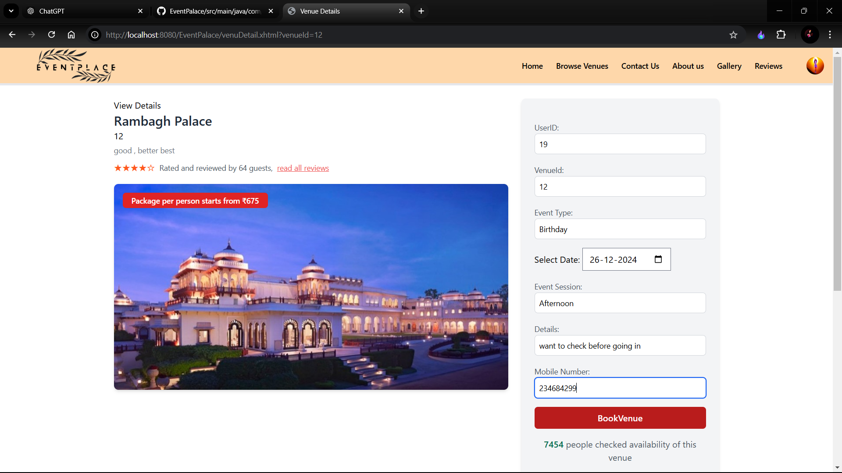

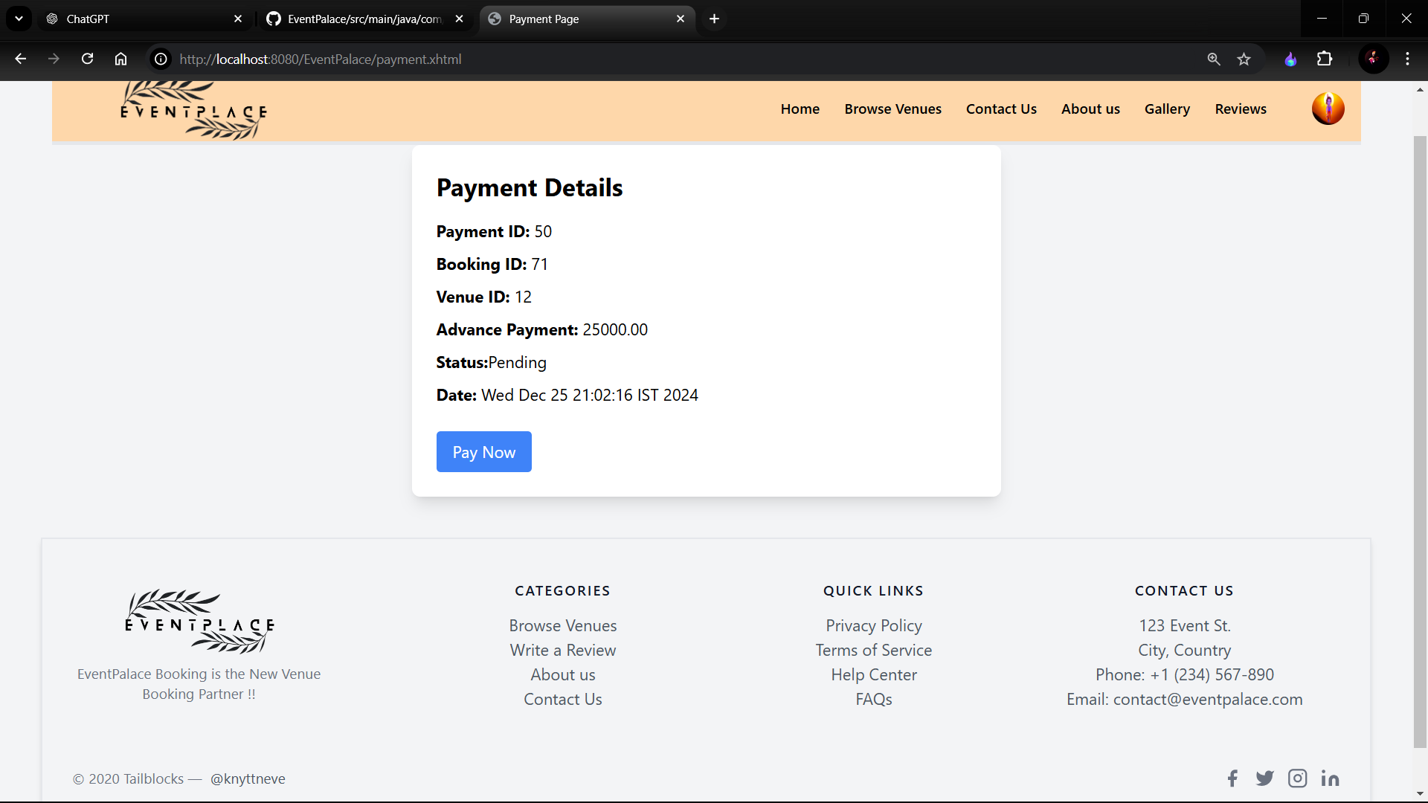

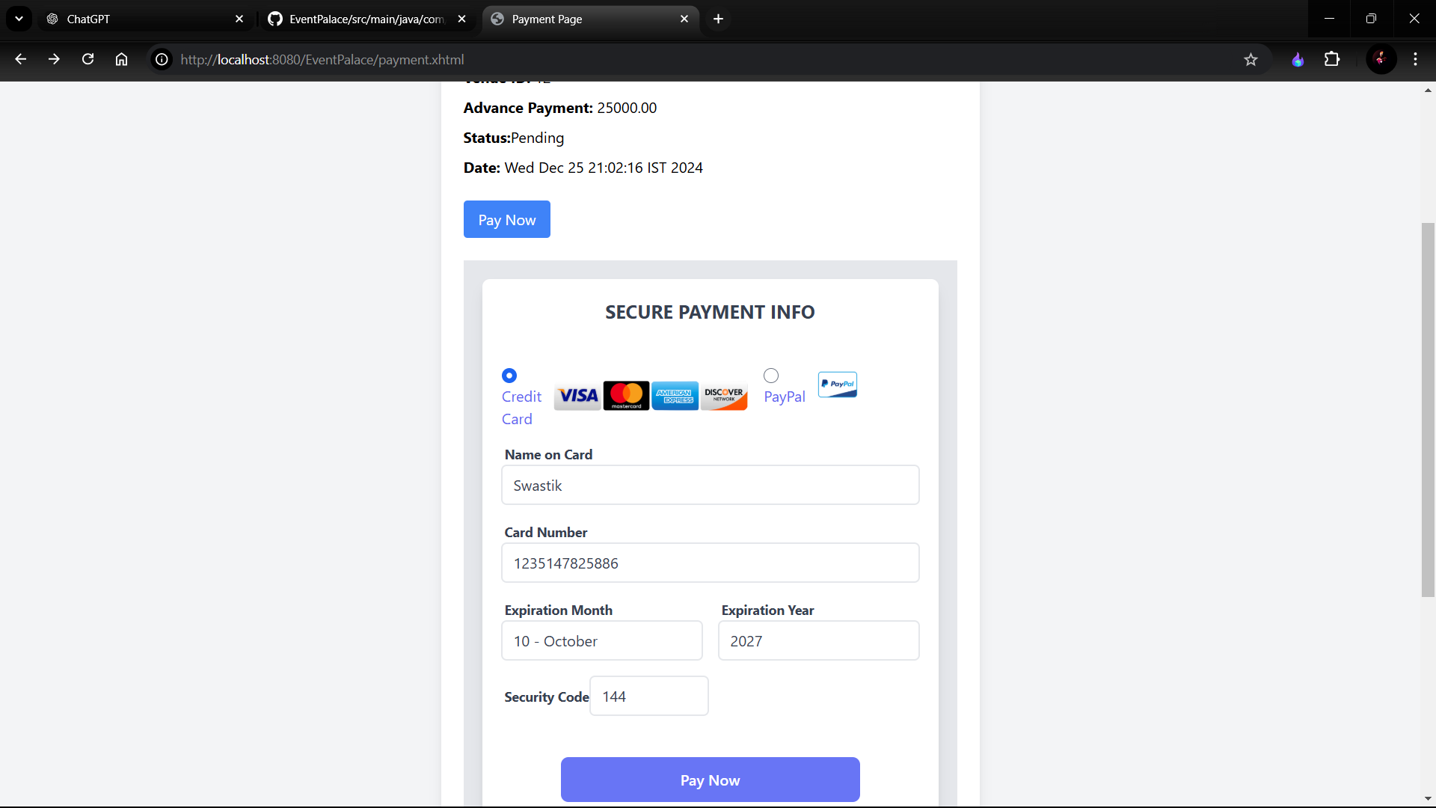

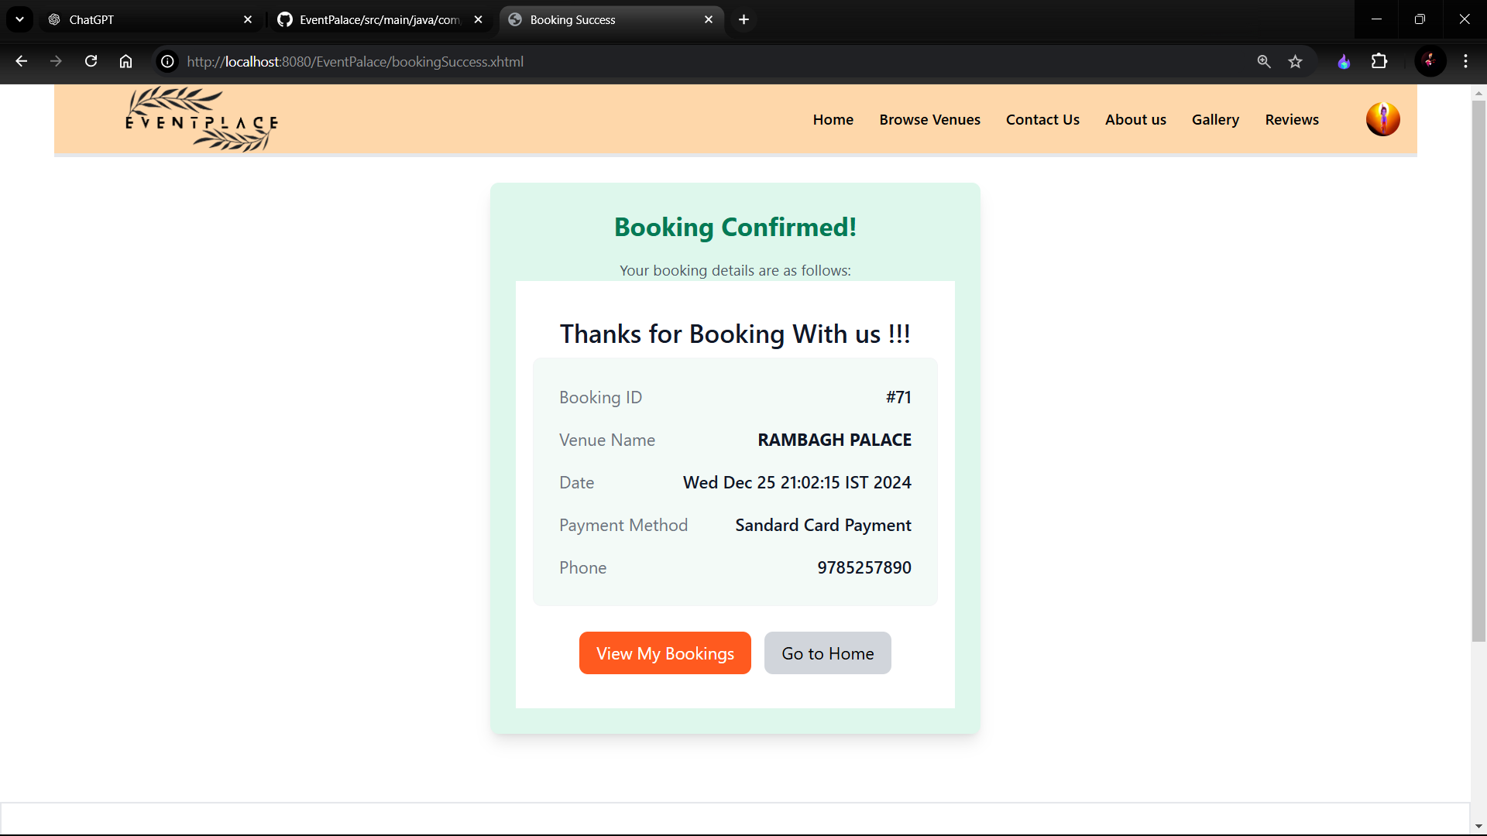

Contact us:  
  
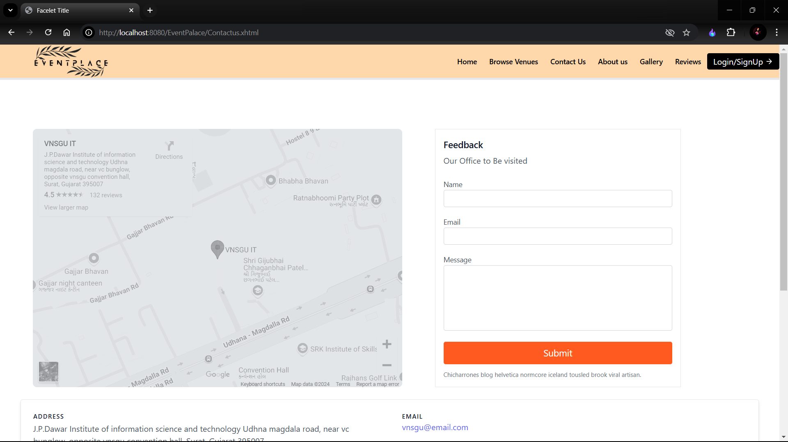

Gallery Page:  
  
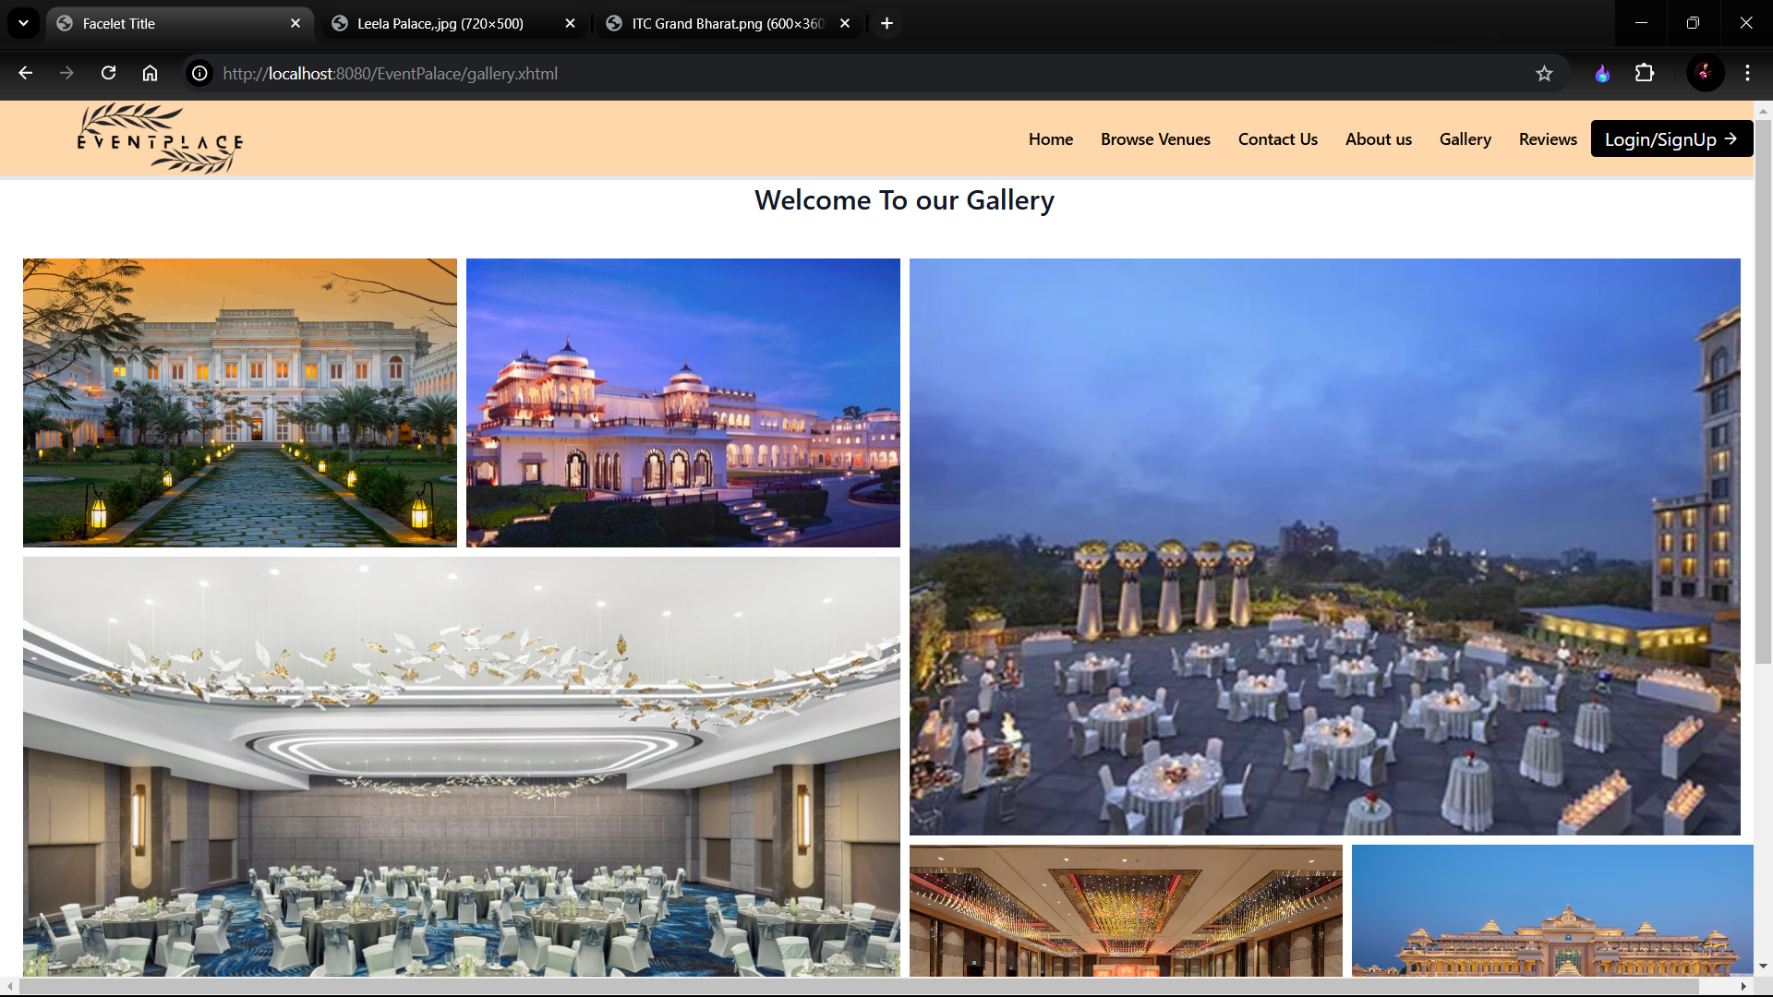

Review Page:

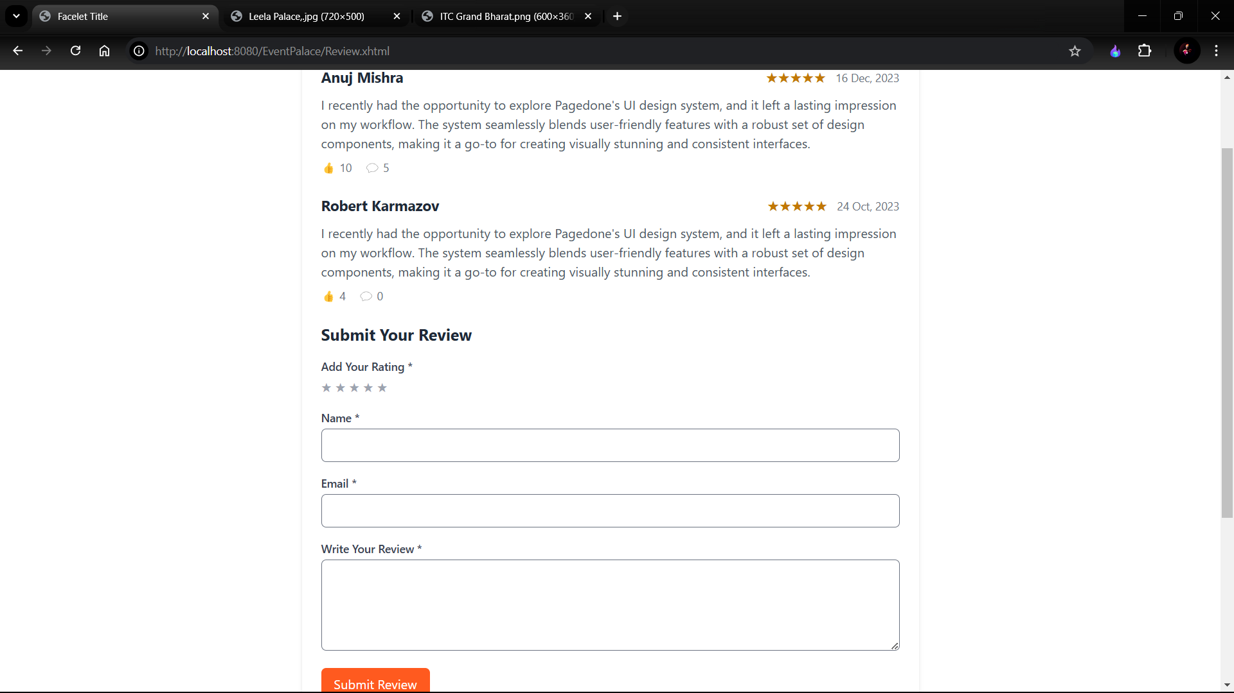

User DashBoard :

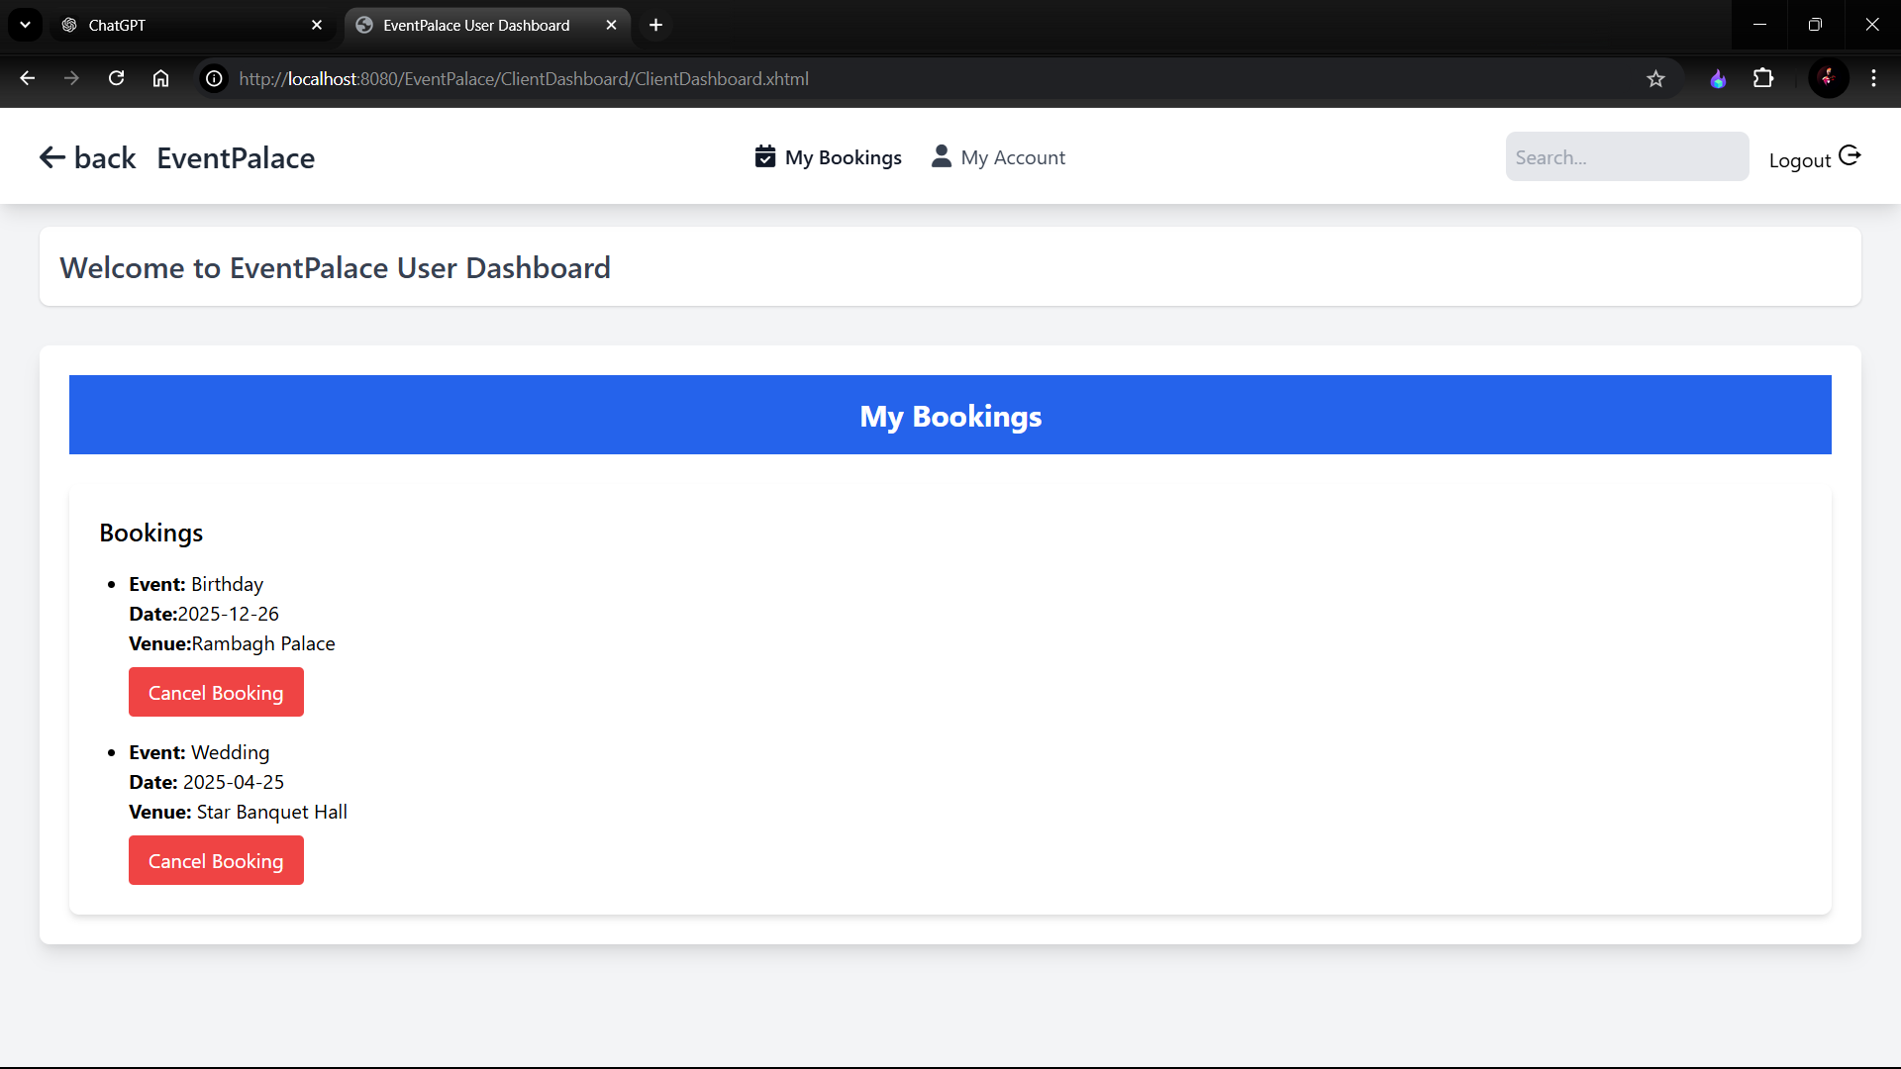

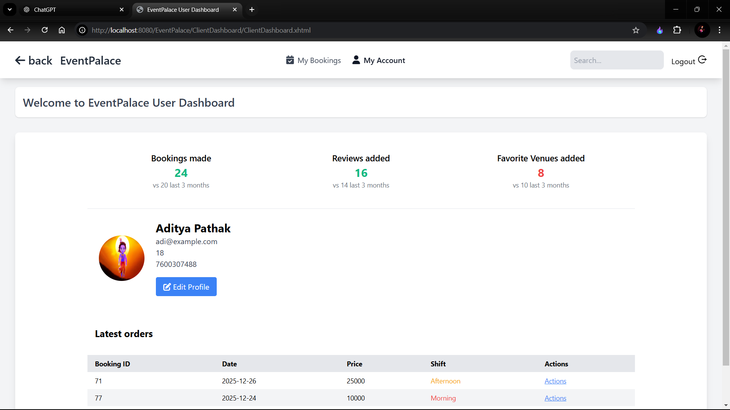

Login Page:  
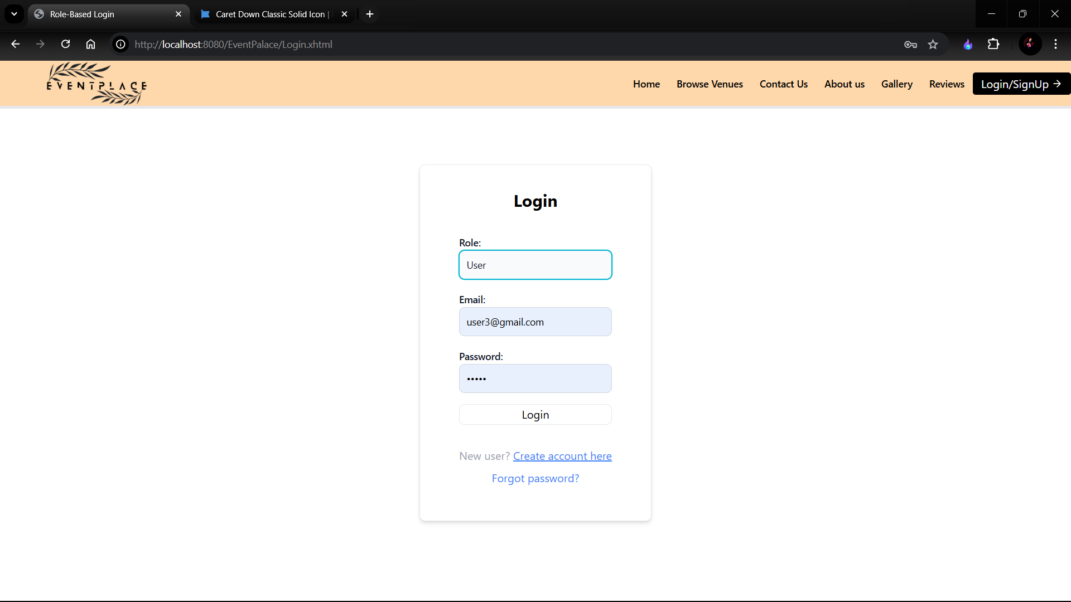

Registration page :  
  
  
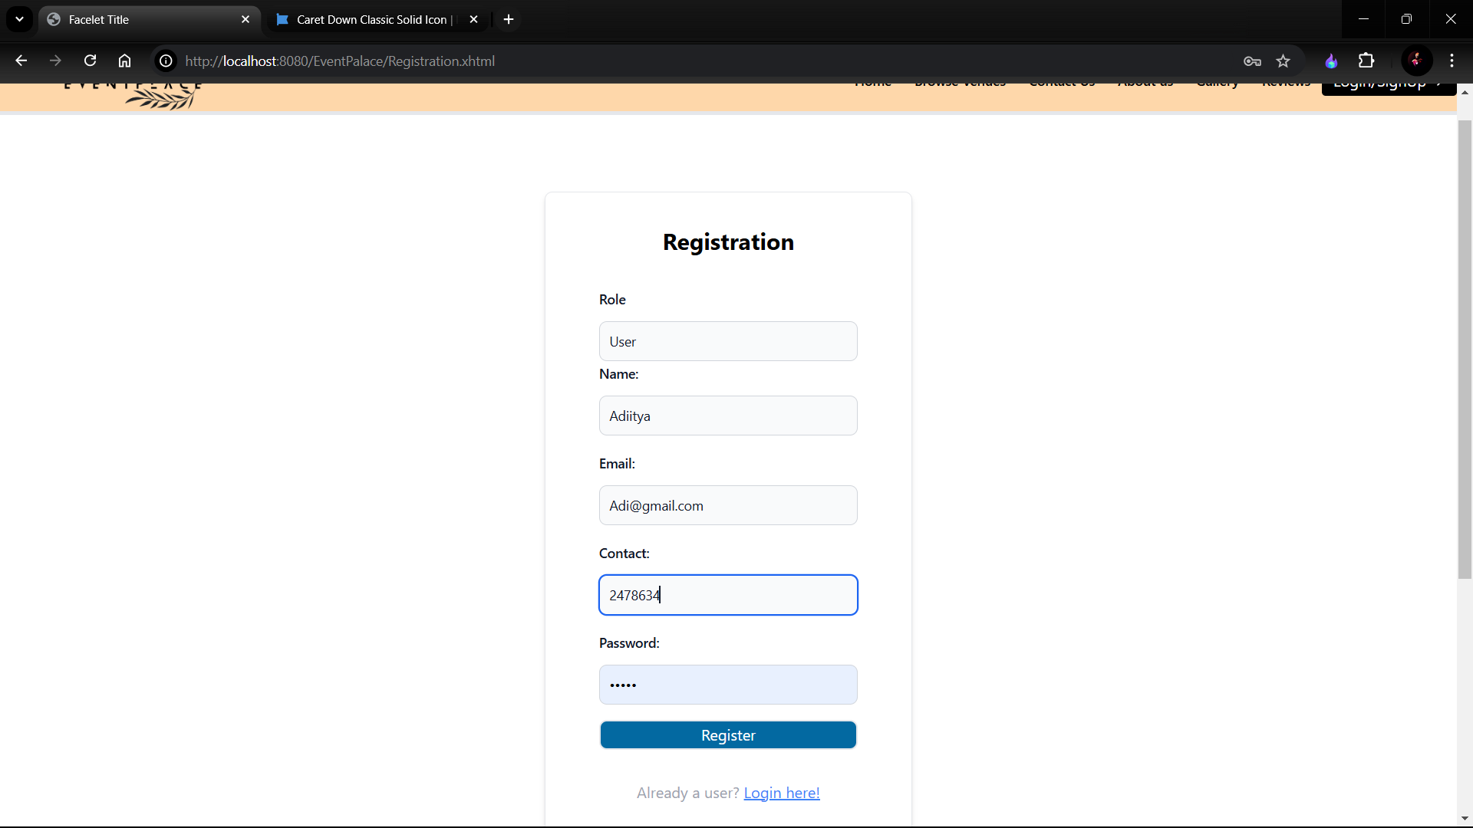

Admin:

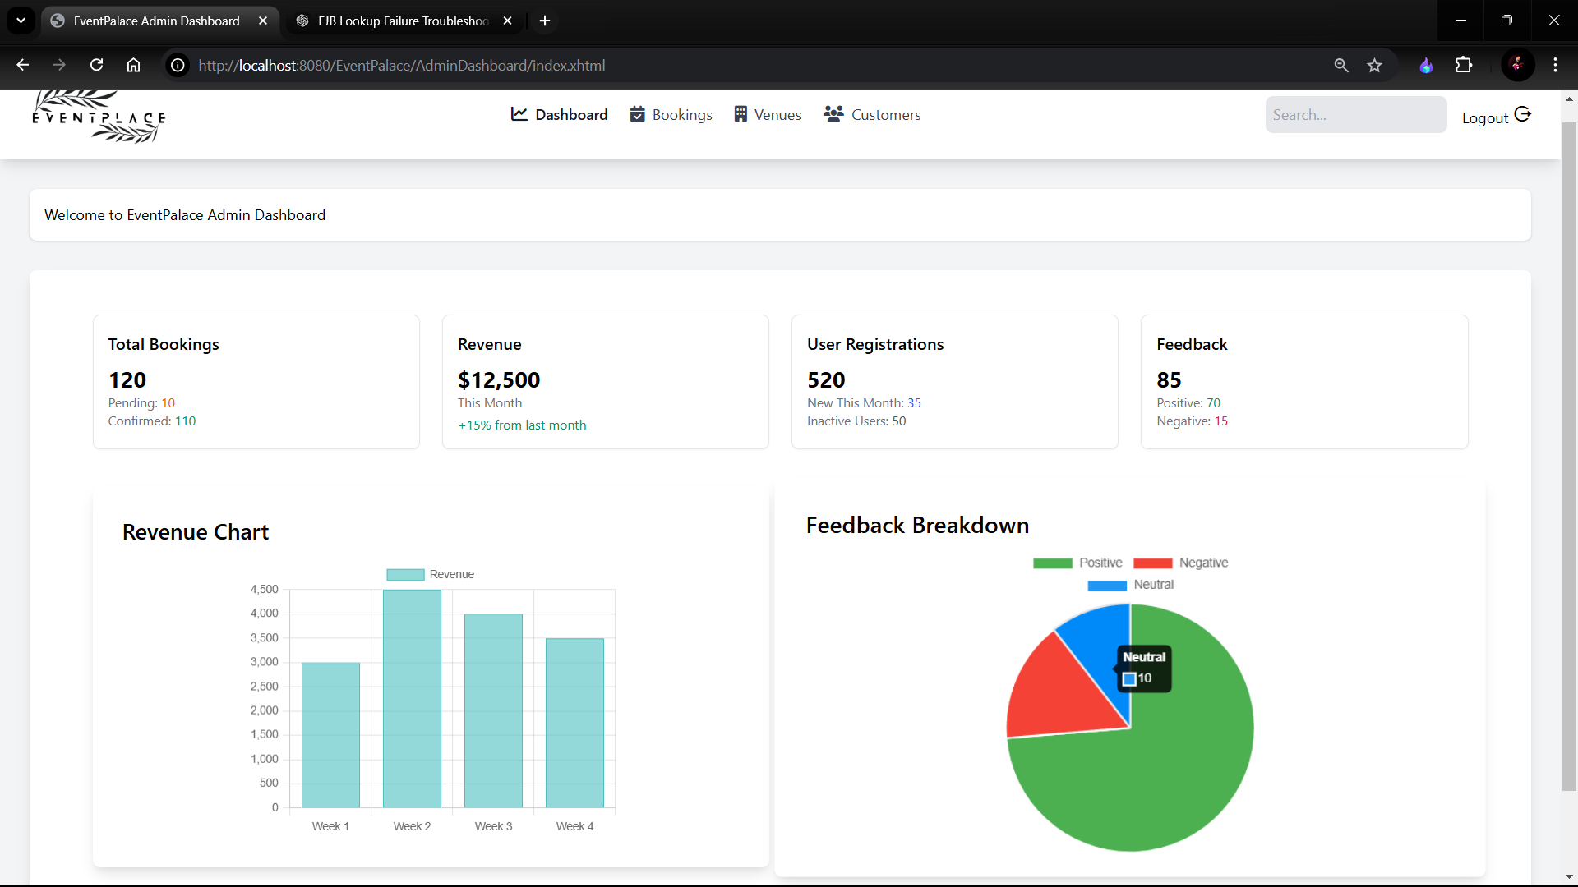

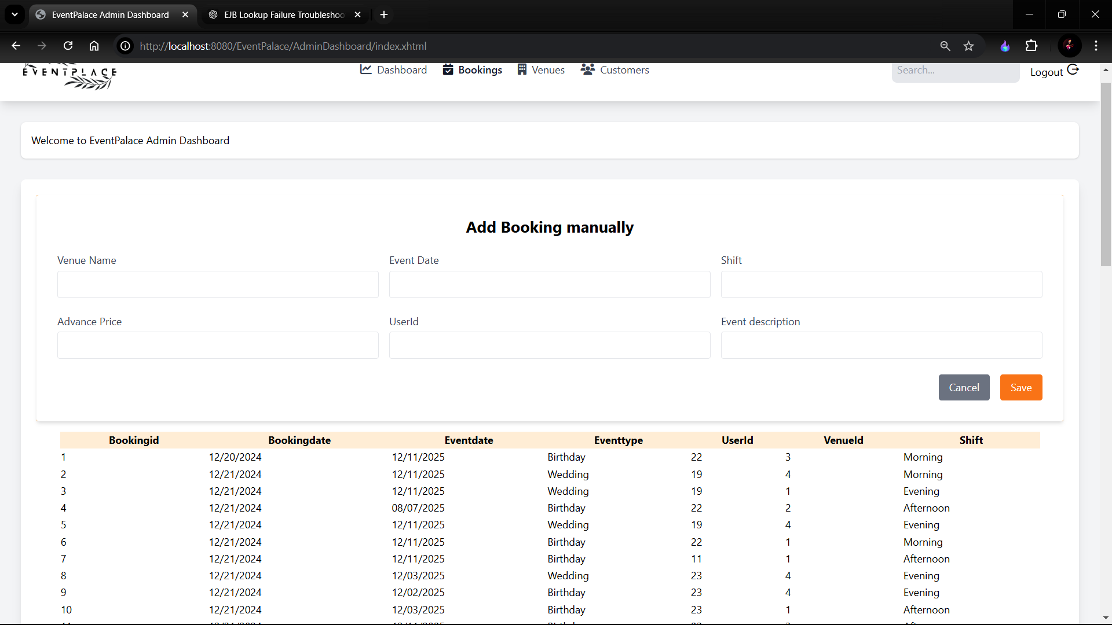

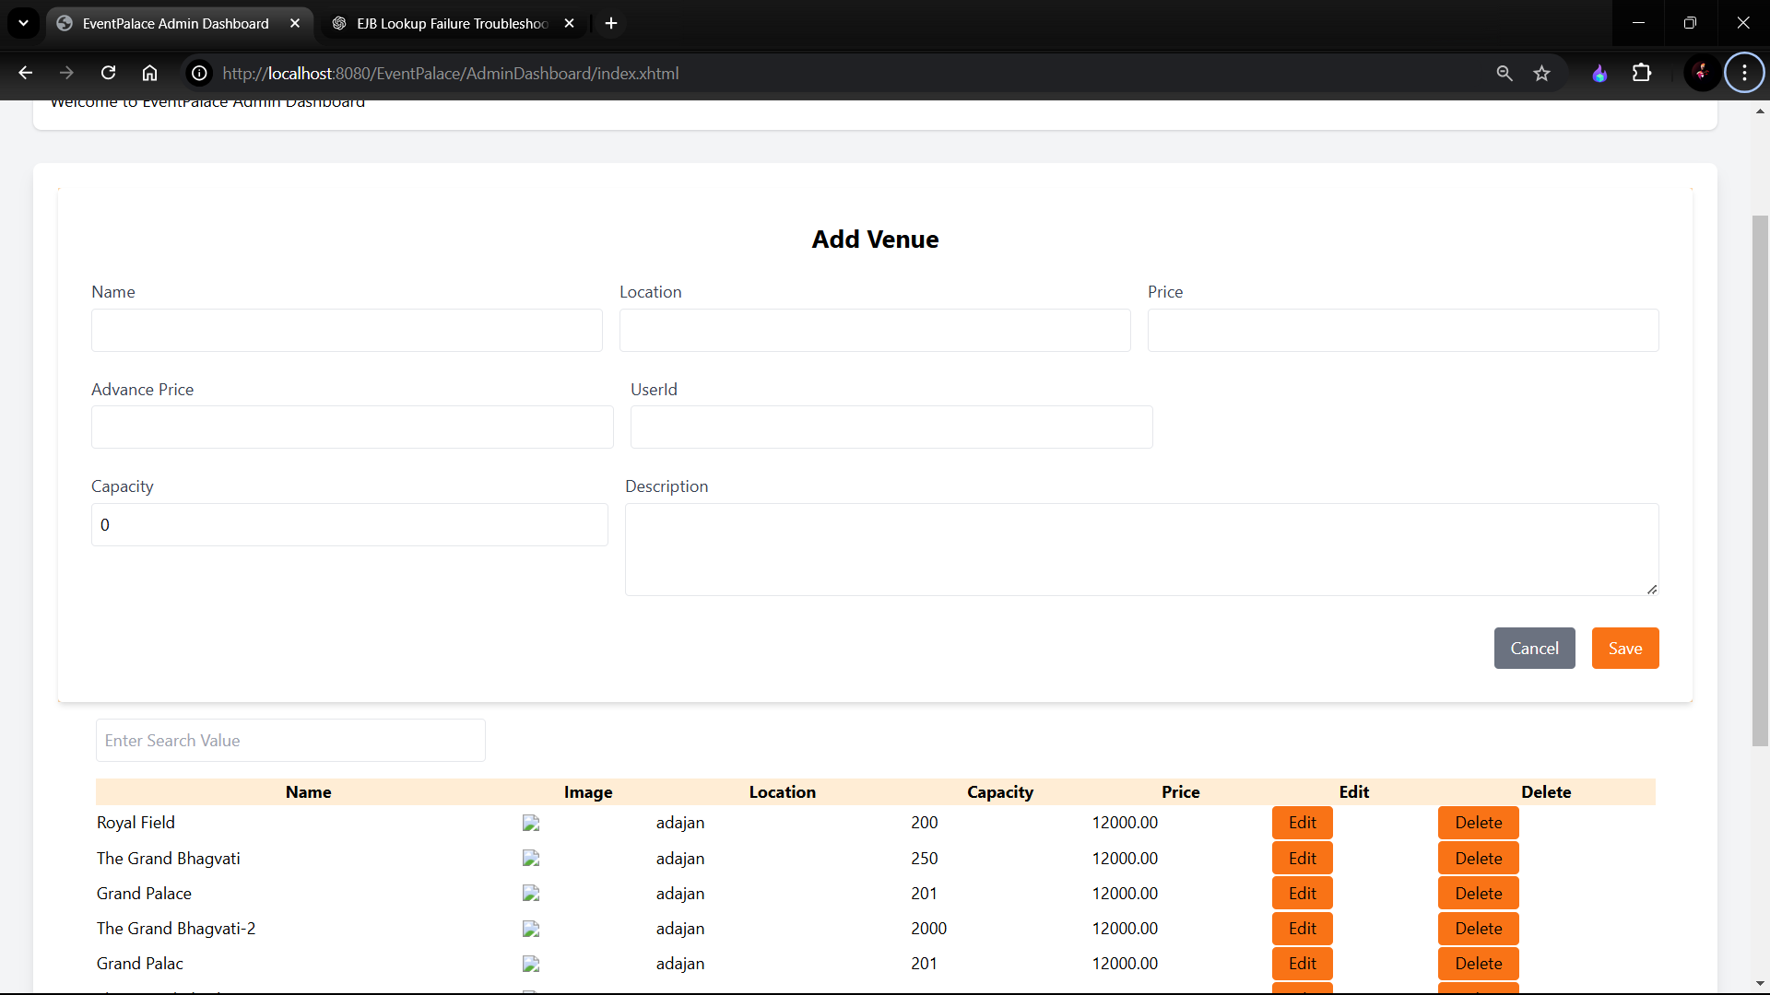

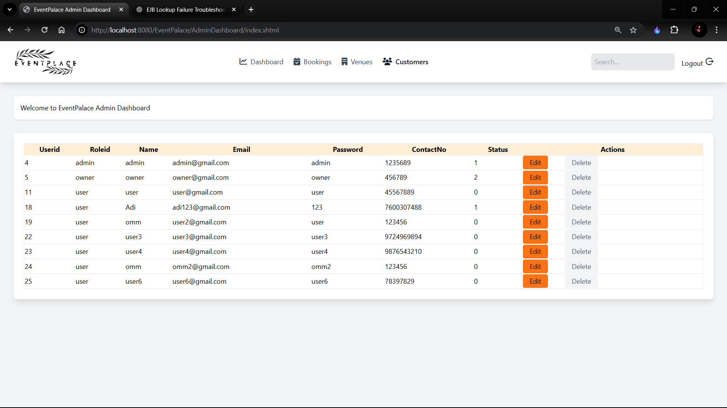

Owner Dashboard:

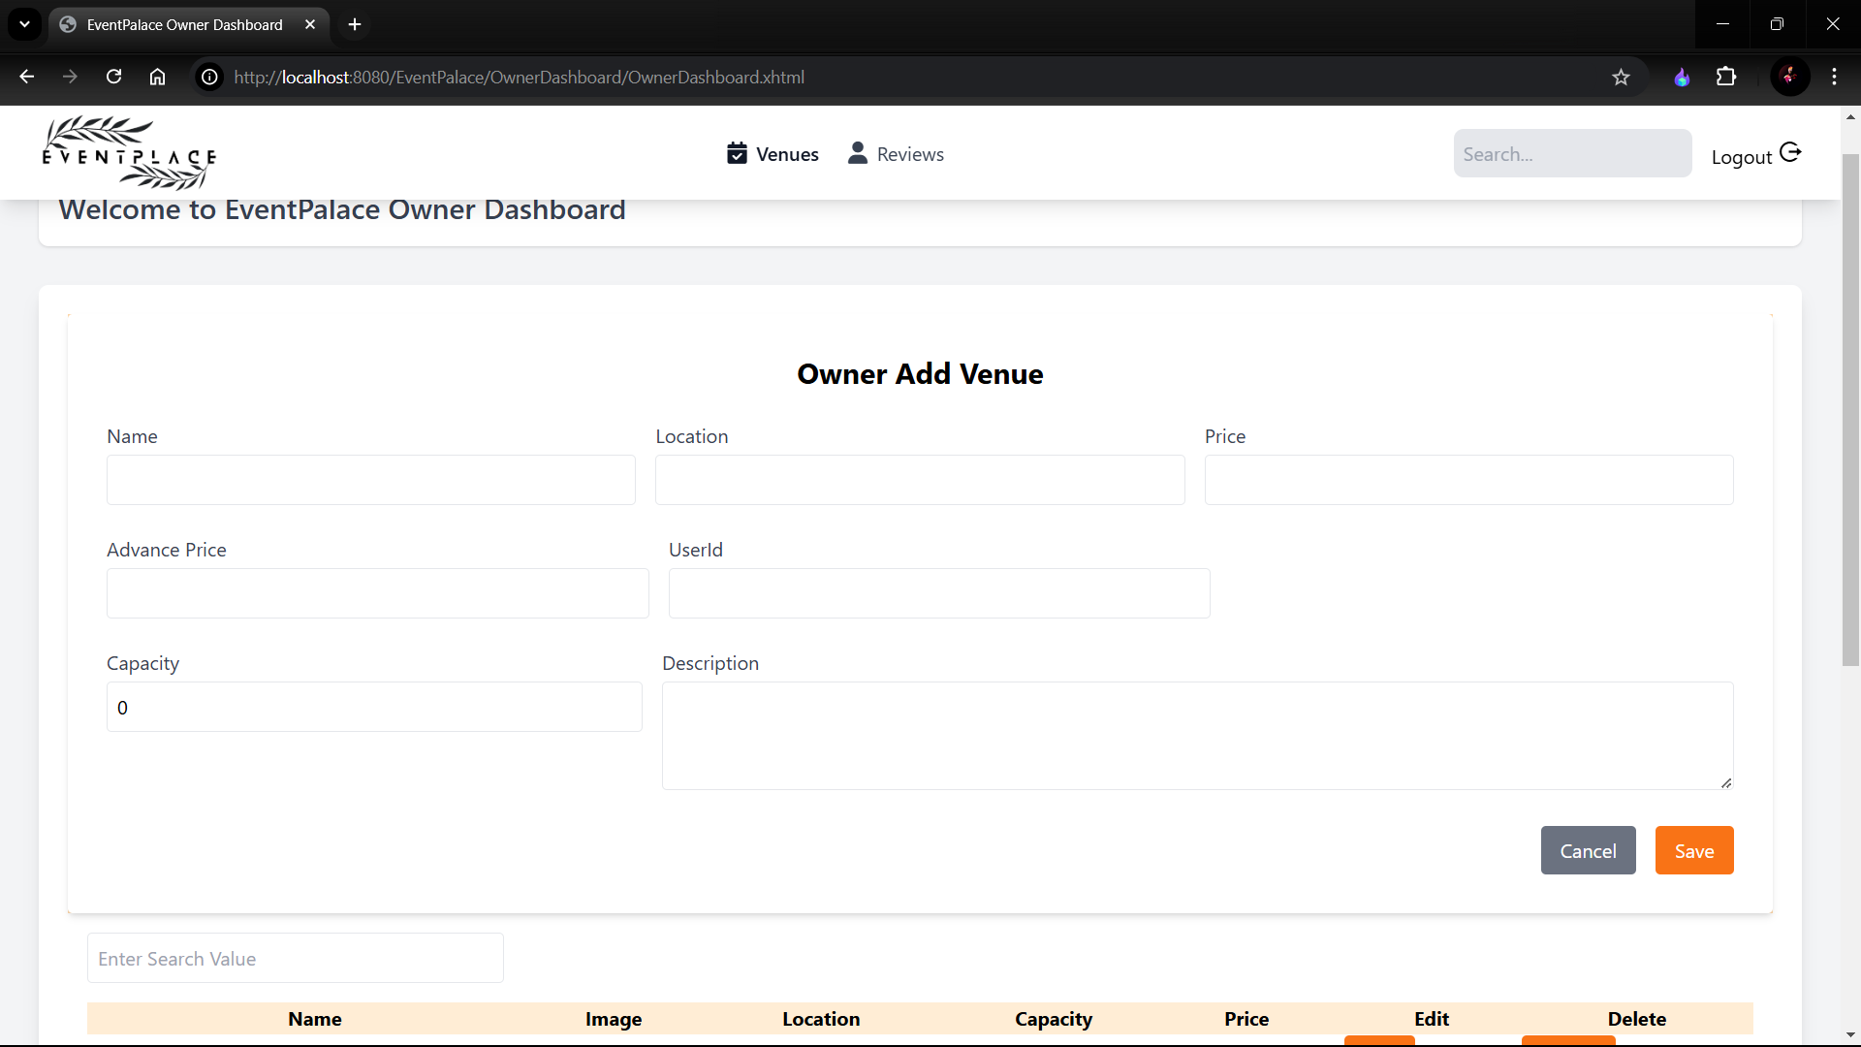

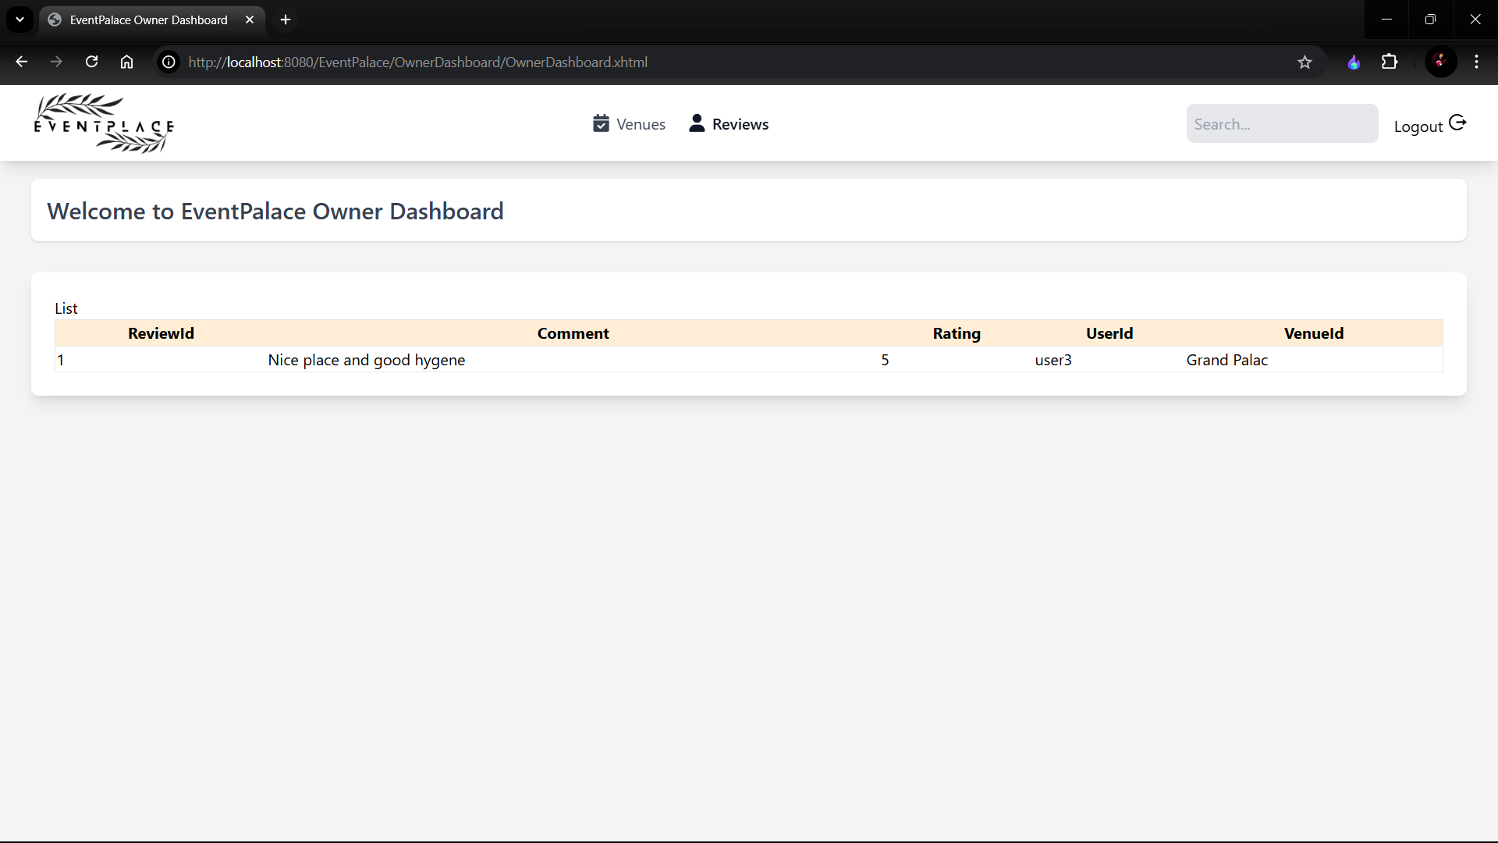

**5.Testing**

|  |  |  |  |  |  |
| --- | --- | --- | --- | --- | --- |
| TEST CASE ID | DESCIPTION | INPUT | EXPECTED OUTPUT | ACTUAL OUTPUT | STATUS |
| Case 1.1:  Case 1.2: | User Login | 1.Email  2. Password | Appropriate message for invalid user  Valid user should be redirected to intended page after logging | Message generated for invalid user  Directed to intended page after logging | Unsuccessful  Successful |
| Case 2:  Case 2.1:  Case 2.2: | User Home Page | Select the option to proceed  Display the Venues  Display proper layout for listing all venue | Test case would open the appropriate page as per option selected by user  Test case would show the appropriate list of Venues  Test case would redirect the user to intended page | Displays desired page  Display proper  Venues  Redirect to intended page after clicking button | Successful  Successful  Successful |
| Case 3: | Package Module | Fill the details to proceed | Appropriate message for invalid details  Appropriate message and relatable Course will be shown | Message generated for invalid details  Display proper Courses. | Unsuccessful  Successful |
| Case 4:  Case 4.1:  Case 4.2: | Details Page | Details of specific package  Enrollment form  Payment process | Test case would open appropriate page with the details of that Course.  Test case would open appropriate page for enroll the Courses  Test case would open appropriate page for payment | Details are generated  Page is directed    Page is redirected | Successful  Successful  Successful |

# 6.Bibliography

This section provides a list of all the references, tools, technologies, frameworks, and

resources that were used during the development of the EventPalace project.

Links

1: <https://www.venuebookingz.com/home>

2: <https://tailblocks.cc/>

3: https://tailwindui.com/components/application-ui/navigation/navbars

**Web Resources**

**1. Stack Overflow:**

**o For resolving programming challenges and enhancing functionality.**

**o URL:** [**https://stackoverflow.com**](https://stackoverflow.com)

**2. MySQL Documentation:**

**o For database schema optimization and SQL query examples.**

**o URL:** [**https://dev.mysql.com/doc**](https://dev.mysql.com/doc)

**Tools and Technologies**

**1. Java: Primary programming language for system development.**

**2. MySQL: Database system for storing and managing project data.**

**3. Apache Tomcat: Server for deploying the web application.**

**4. NetBeans IDE: Integrated development environment used for coding and debugging.**

**5. Lucidchart: Tool for creating system diagrams such as ERDs and Use Case**

**Diagrams.**

**6. Postman: For testing and validating APIs during development.**